

NAME: Aneel kumar

ID NO: BIT-23F-033

SUBJECT: LAB NO06

TEACHER: MIS AQSA

LAB: O6

task

.Write a Python function that takes a number as input and returns the sum of its digits.

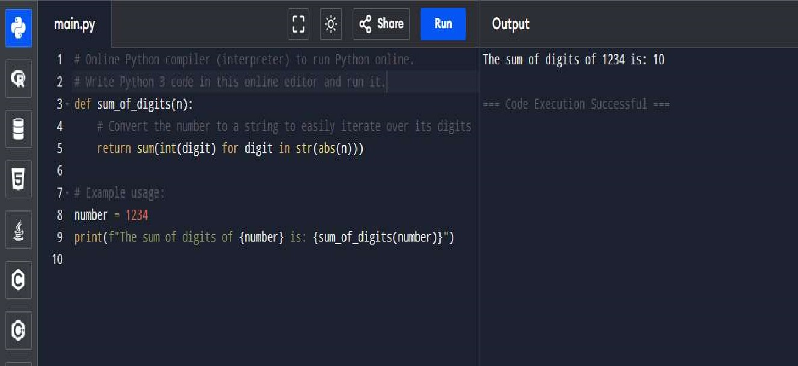

TASK2

Write a Python function that takes a sentence as input and returns the number of words in

task3. Write a Python function that takes an integer and returns whether the number is even or odd.

